**Winter School Project: Introducing Modifications to Lakeland**

**Huayi Lin, Enver Miguel, and Claire McIlvennie**

**ABM Winter School, January 2018**

1. **Motivation and Research Question**

The original Lakeland model presents agents making who make decisions regarding how to allocate their time between fishing and mining attempt to maximize their utility over the course of time. Their utility is based on their income and leisure time (time not spent either fishing or mining), which is calculated based on a simple Cobb Douglas function. Agents make decisions according to the consumat framework of decision making in which agents make decisions according to different cognitive processes given their levels of need satisfaction and uncertainty about their expected versus experienced utility.

In the model as originally coded, the agents live in an abstract world, operating without consideration of spatial or temporal dynamics, with perfect information about all other agents in the system and levels of resources. In this model, agents essentially act as rational actors seeking to maximize their utility over time. However, while the original model provides interesting insight on how agents make tradeoffs between certain resources given various conditions, literature on decision making has shown that many decisions are made under conditions of bounded rationality due to imperfect information and social dynamics.

As a result, this project aimed to introduce aspects of bounded rationality and imperfect information to the Lakeland model and investigate the implications of these changes on resource extraction and the dominant cognitive processes used to make time allocation decisions.

1. **Brief description of changes to base model (new functions, variables, entities, interface, details can be documented in Netlogo infotab)**

We attempted to introduce aspects of bounded rationality into the Lakeland model through considerations of spatial dynamics, varied preferences, and memory.

**Spatial Dynamics and Imperfect Information:**

A number of changes to were made to the original code to introduce spatial components to the model. First, agents were randomly distributed across the world and color coded to indicate whether their dominant activity was fishing or mining. Agents can also increase or decrease their size depending on time allocated to the activity.

Second, code was added to allow agents to move around the world, view varying amounts of the world, and move towards similar others (flocking). These changes impacted agents decision making processes when they were making decisions under the mental models of imitation or inquiring, which require gathering information from other agents to make time allocation choices.

* **Movement:** Code was added to allow agents to move around the world while making decisions given different input parameters. A slider was added to the interface to determine the speed, ranging from 0 (not moving) to 10 (moving 10 patches per timestep).
* **Neighborhood Radius:** The neighborhood radius was added to vary the percent of the world agents could draw information from when making decisions. This radius could be varied using a slider in the interface, which ranged from a radius of 0 (you could only see yourself) to 50 (could gather information from agents in a 50 patch radius).
* **Flocking:** Finally, a flocking function was added to tell agents to move in line with the nearest turtles with the same career. This function was based on the flocking model in the Netlogo library. Flocking can be turned on or off through a switch on the interface and flocking parameters adjusted through sliders. Similar others are defined as agents who spend the majority of their time on the same activities (either fishing or mining, defined as their career).

**Varied Preferences and Imperfect Information:**

We also sought to introduce aspects of imperfect information and bounded rationality through the utility function. The original model included a slider to parameterize the value for gamma, but all agents maximized their utility based on the same gamma value, or essentially all agents had the same preferences for income and leisure time.

In this project, we added the ability to vary gamma across agents in the world. A switch was added to the interface to turn this function on or add and a slider indicated the extent to which gamma varied (from zero to one). This added imperfect information into the model since agents would not know whether or not other agents are maximizing utility based on the same or different preferences when they look at the world around them.

**Memory**

We spent much time considering how element of memory could be added to the model, but did not ultimately implement any functions to test the implications of remember various aspects of the world, such as time spend fishing or mining, or resource stability.

1. **Model exploration (scenarios/experimental design, parameter settings, etc.)**

We ran three primary experiments to explore the impact of our model additions. In each of these experiments, we used the following input parameters from the original model:

* Agents had varied skills with variation in skills set to 0.5
* All agents had the same thresholds for uncertainty (0.1) and need satisfaction (0.2).
* Agents experiences stochasticity in fish catch
* Resource recovery occurred with a value of 0.1

In analyzing the results, we looked at each conditions impact on resource extraction (both fish and gold mining) and cognitive processes used to make decisions. The simulations were run for 500 ticks and averaged over 10 simulations for each condition.

**Experiment 1:** **Impact of Speed and Neighborhood Radius**

The first experiment looked to explore the impact of agent movement speed and their neighborhood. We tested neighborhood radius’ of size 0, 10, 30, and 50 and speeds of 0, 3, 7, 10 (in both cases roughly speeds/neighborhoods of small, medium, and large sizes). For this experiment, gamma was set to 0.5 and flocking was off. Since agents can only seek information from a subset of the world, we hypothesized a small radius may not give the turtles an accurate picture of the world and that they may be satisfied less often. Movement around the world at greater speed would increase the number of agents each agent interacts with, which could reduce this impact.

**Experiment 2:**  **Neighborhood Size, Speed, and Flocking**

The next experiment looked to explore the impact of having agents move towards similar others. We hypothesized this may reduce uncertainty and therefore increase cognitive processes around imitation or inquiring. When turtles are flocking, they may have greater chance to meeting the turtles with the same career. Thus the turtles may have bigger chance to maintain their current career than changing their career.

We employed the same parameters as experiment 1 but set flocking to true.

**Experiment 3:**

The final experiment looked to explore the impact of different values of gamma and variability of gamma on cognitive processes and resource extraction. We explored this over gamma values for 0.3 (strong preference for leisure time), 0.4, 0.5 (equal preference leisure time and income), 0.6, and 0.7 (strong preference for income). We ran simulations with variability of gamma both off and on with 0.5 variability.

In the initial model, all agents sampled from agents with the same preference levels for income and leisure time. Introducing variation in these levels would mean agents might be inquiring from or imitating agents who have different preferences than them. We hypothesize this could lead to lower levels of satisfaction thus more optimization/inquiring behavior.

1. **Results**

**Experiment 1:**

In experiment one, results indicated that speed and neighborhood do have some impact on resource extraction. Figures 1 and 2 show that increased neighborhood size increases extraction of both fish and gold resources over time, with the largest impact moving from a neighborhood of zero to 10 patches. Initially speed does not seem to impact resource extraction, but for larger neighborhood radiuses it appears moving (speeds 3,7,10) and not moving (speed 0) may have some impact on resource extraction.

**Figure 1**: **Fish resources remaining by speed and neighborhood radius**

**Figure 2: Gold resource remaining by speed and neighborhood radius**.

To investigate these initial results and the drop in resource extraction when moving from a neighborhood / speed of 0 and up, we ran a sensitivity analysis on smaller speeds and neighborhood sizes, experimenting with neighborhood sizes of 0-6 and speeds of 0-3.

**Figure 3. Fish resource remaining by speed and neighborhood size**



**Figure 4. Fish resource remaining by speed and neighborhood size**



Figures 3 and 4 show that just a small increase in neighborhood size results in a relatively large increase in resource extraction, suggesting that awareness of even a small percentage of the world encourages agents to spend more time fishing and mining to maximize their utility. In addition, while we do not see any significant impacts for changing speed between 1, 2, and 3 patches per tick, we do see an effect of increasing speed from 0 to 1, suggesting that movement of any kind, mixing with a greater percentage of the world, results in greater resource extraction.

**Experiment 2:** We did not see any major impacts of flocking on resource extraction. However, we did notice that agents seemed to become more uncertain when flocking was turned on and they moved towards similar others. This was an unexpected finding as we hypothesized moving towards others with similar careers would reduce an agents’ uncertainty about their expected utility.

**Figure 5.** **Impact of flocking on average agent uncertainty**

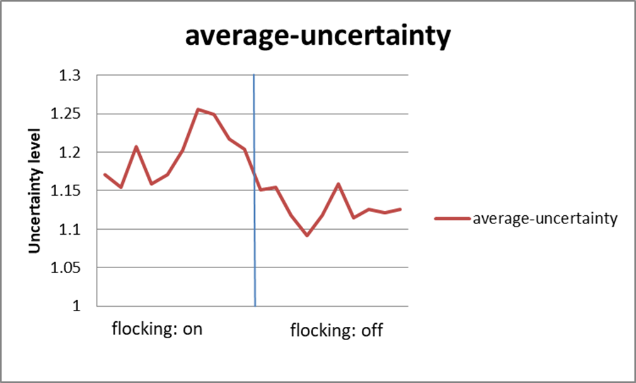

**Experiment 3:** **Variability and Heterogeneity in Gamma**

Results of experiment three indicated that there was no effect of introducing heterogeneity in the value of gamma on either resource extraction or cognitive processes of the agents. However, we did observe that varying gamma between 0.3 (strong preference for leisure time) and 0.7( strong preference for income) produced interesting effects.

Figure

1. **Reflections on results and exercise**

Even a simple model can generate unexpected results.

Future study can include following elements:

1. Add bias sampling of the information, memory, and competition into the model.

2. Consider additional spatial modifications, for example, add location of the lake and the mining site. Agents consume energy when fishing, mining or transferring from one career to another career.

3. Add other needs to the utility function, for example, environmental concerns, security, belongingness to the community.

***Please include your Netlogo code***